IS PEPSE OK CAMPAIGN

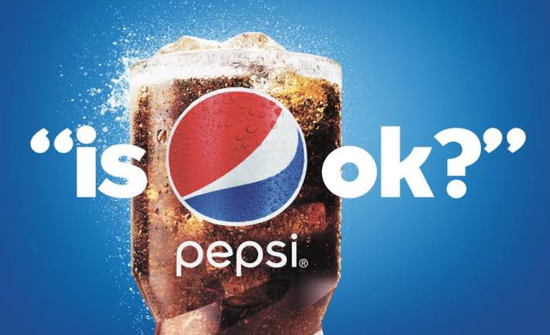

In 2019, Pepsi faced a decline in sales, primarily due to changing consumer preferences. **The rise of healthier alternatives and growing awareness of the negative effects of sugary drinks led to a decrease in demand for Pepsi’s signature soft drinks**. Additionally, the company faced criticism for its contribution to plastic pollution and its impact on the environment. To address these issues, Pepsi introduced its “Performance with Purpose” vision, which focused on creating sustainable products, reducing waste, and promoting healthy living. **The “Is Pepsi OK?” campaign was born out of this vision, with the goal of communicating the company’s commitment to social responsibility and environmental stewardship.**

**STRATEGIES FOLLOWED BY PEPSI:**

Directly addressing brand challenges can be effective, especially with humor and star power. A well-crafted campaign can turn a perceived weakness into a memorable strength.

Multi-channel campaigns with offline and online experiences create synergy and amplify reach, ensuring the message resonates with a wider audience across various platforms.

Engaging fans through interactive events and social media strengthens brand loyalty and conversation, fostering a sense of community and shared experience.

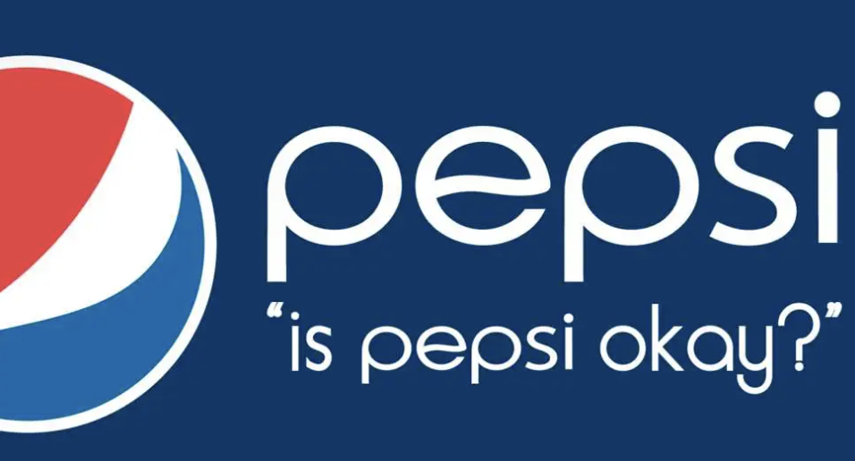

**CONCLUSION :**

Pepsi’s “Is Pepsi OK?” campaign demonstrates the power of acknowledging and subverting brand perceptions. The campaign’s humor, celebrity leverage, and multi-channel execution successfully shifted brand image, increased engagement, and boosted sales. This case study offers valuable insights for marketers planning bold and impactful campaigns that address brand challenges and connect with audiences in meaningful ways.

So what exactly was the purpose of this advertisement? Other than the several celebrity cameos that probably had the viewers wondering, “How much did they actually spend to pay these public figures?”, it also addressed the big elephant in the room, “How is Pepsi still around when Coca Cola holds the highest market share in the beverage market?”. Not only was this thirty second commercial a bold statement that yes, Pepsi is in fact more than okay, but it also told the audience that this brand that has been around for over a 100 years is still going strong. With big supporters like Lil’ Jon and Cardi B, the company makes a point that they still have a strong customer foundation.